**How to Create a CronJob in OpenShift to Call a REST Endpoint Periodically**

**Steps to Create CronJon on your Project**

* Go to your OpenShift Web Console and select the dedicated project

NOTE: You can create your OpenShift Online cluster from [here](https://www.openshift.com/products/online/)

* From the “**Add to Project**” drop down list in the top-right corner, select “**Import YAML/JASON**”
* Copy the content of the file **cronjob.yml** from [this repo](https://github.com/samme4life/openshift-cronjob)
* Paste the yaml file content and click “Create”

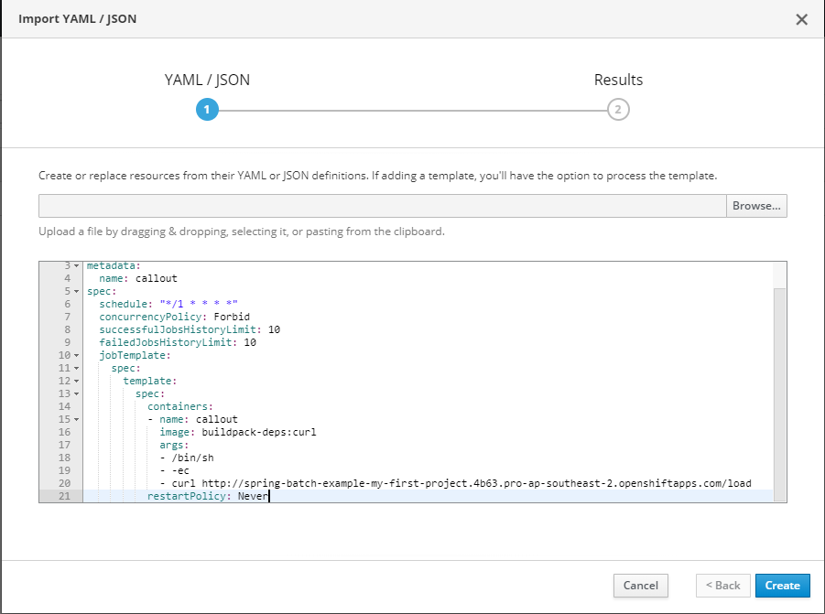

* Click “Create Anyway” despite the warning

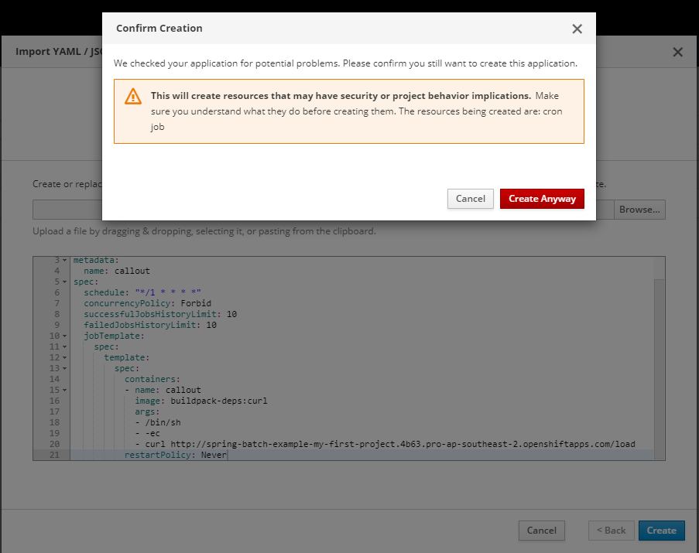

* Then the CronJob will be imported into the cluster and a pod will be created

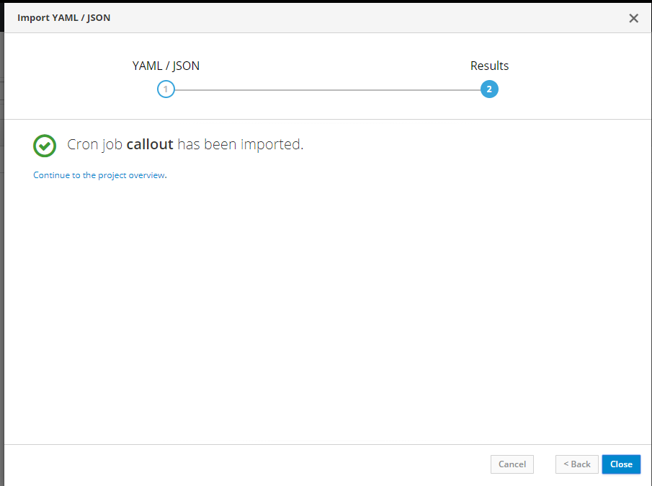

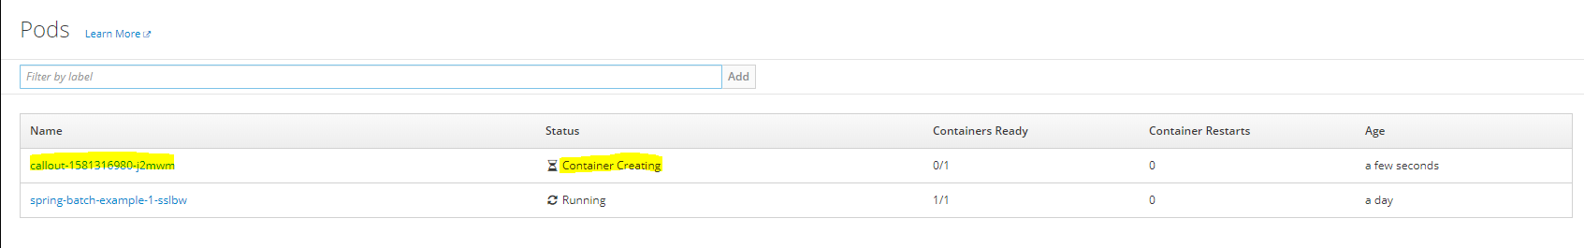

**Reference**

* OpenShift Documentation on Jobs & Cron Jobs: "<https://docs.openshift.com/container-platform/4.1/nodes/jobs/nodes-nodes-jobs.html>"
* StackOverflow Thread I raised: "<https://stackoverflow.com/questions/60135077/run-a-kubernetes-cron-job-from-openshift-to-call-a-rest-endpoint-periodically>"
* StackOverflow Thread where I found the solution: "<https://stackoverflow.com/questions/47203080/call-endpoint-from-kubernetes-cron-job>"

**Important OC commands**

* login to a certain OpenShift cluster: oc login --server=<server_url>
* to delete a cron-job: oc delete cronjob/<cron_job_name>